# Tiled Maps

Open Tiled and create a new map. Set the orientation to Orthogonal and the Tile Layer Format to XML. We are using XMLSerialization to deserialize our tmx file in Unity and we are going to be working with Orthogonal type maps. Please not that setting the Tile Layer Format to CSV (Comma Separated Values), Base64 (uncompressed), and Base64 (zlib compressed) will not work with the xml deserializer.

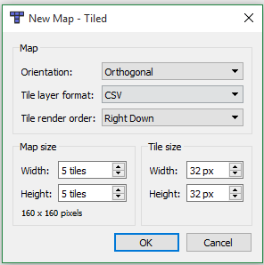

To verify you have the correct settings, Notice that I set the Tile layer format to CSV when I created my map and this needs to be changed, on the toolbar select Map->Map Properties

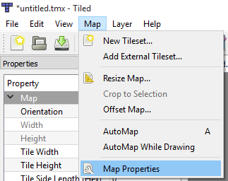

You should see something similar in the properties window

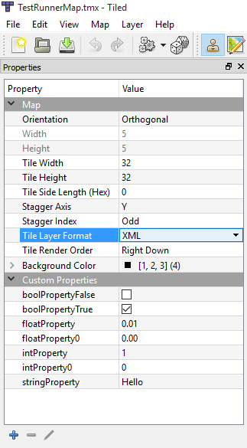

Notice that I also changed the background color to Red 1, Green 2, Blue 3 and the Alpha 4 this is not required to follow along with this tutorial this is for testing purposes and also to show you how to convert this value to a color that Unity can use in a later tutorial. Also note that I have added some of the different types of properties with different values for testing purposes

The Tile Width and Tile Height you should set to the smallest tile size in your tilesets. If you are going to have one tileset that has 64x64 tiles and one tileset that has 32x32 tiles then set this to 32x32. The tiles from the liberated pixel cup are 32x32 and the tiles from 2D Pixel Tiles are 32x32. So I will be setting my tile height and width to 32. Make sure that you use a texture that is located in your Unity Project Maps->Tilesets.

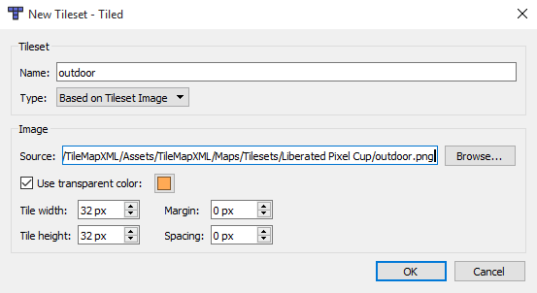

Save your map in Your Unity Project Maps Folder.

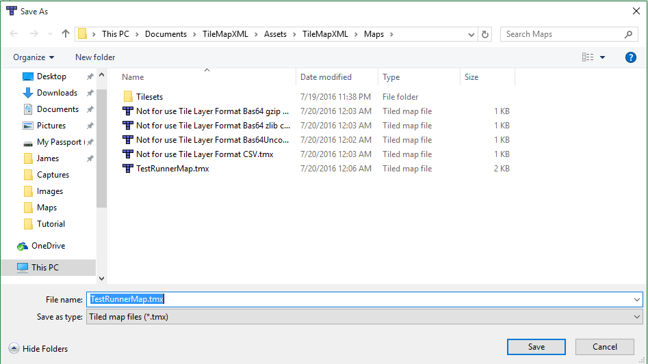

And in Unity you should see it in your Project Layout

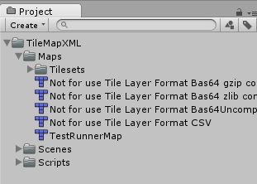

After we create the editor script in Unity to import our tmx maps and textures it will not matter where the tileset texture is and where you save the Tiled map, we are only doing it this way for now to make it easier on us to start.